Course Project Report: Q3A
Course: EE200 – Digital Signal Processing
Module: Q3A: Sonic Signatures – ‘Magical Mystery Tune’

- Official Assignment Question Objectives & Requirements
As outlined in the project brief, this report addresses and satisfies the following explicit milestones:
- DFT vs. Spectrogram: Plot the DFT magnitude of an entire song to show why a single Fourier transform loses time information, and explain how a spectrogram resolves this by using a sliding window.
- Resolution Analysis: Compute and plot the spectrogram of a provided song twice—once with a short window and once with a long window—and describe observations regarding time vs. frequency resolution.
- Constellation Map: Extract the local maxima (strongest peaks) standing out from their surroundings and plot this ‘constellation’ of points.
- Combinatorial Hashing vs. Single Peaks: Pair nearby peaks into compact hashes. Repeat the matching using single peaks on their own instead of pairs, compare the resulting offset histograms, and explain why joining two peaks into a single fingerprint makes a correct match so much more decisive.
- Robustness Testing: Add increasing amounts of noise to find how far the system can be pushed before failure. Then, shift the query in pitch (or stretch in time) and explain why a small pitch shift defeats the identifier even though the song sounds identical to a human. Suggest one architectural change to make the system more robust.
2. Global DFT Magnitude vs. Short-Time Fourier Transform (STFT)
A single Discrete Fourier Transform (DFT) computed across an entire track calculates the net frequency coefficients present throughout its absolute duration:
$$X(f) =\sum_{n=0}^{N-1}{x[n]e^{-j(2π/N)kn}}$$
While the magnitude |X(f)| identifies which musical pitches are present, all temporal context is collapsed. The transform is blind to the sequence of events: a song containing a progression of note A followed by note B yields a nearly identical global frequency magnitude profile to one where those notes are played simultaneously as a chord, or in reverse order.
The Spectrogram Solution
To preserve timing, we introduce the Short-Time Fourier Transform (STFT). By sliding a localized window function w[n] along the signal, we capture an evolving sequence of localized frequency snapshots. Stacking these slices side-by-side produces a spectrogram matrix mapping Time (X-axis), Frequency (Y-axis), and Magnitude Intensity in dB (Colour depth).

the query song that we have taken is ‘Bohemian Rhapsody.mp3’

3. Window Length Experimentation (Time vs. Frequency Resolution)
The structural rendering of a spectrogram is tightly bounded by Heisenberg’s Uncertainty Principle / Gabor Limit in signal processing ( Δ t •Δ f $≥\frac{1}{4π}$). Testing two distinct configurations reveals the operational trade-off:
Configuration A: Short Window (nperseg = 256)
- Observations: Visual output shows vertical smears. Transient strike points (such as drum hits or crisp string plucks) are perfectly defined along the time axis, but individual frequency channels blend into wide, blurry bands.
- Inference: High time resolution (Δ t) sacrificed frequency resolution (Δ f).
Configuration B: Long Window (nperseg = 4096)
- Observations: Visual output transforms into sharp horizontal bands. Stable musical notes and fine harmonic lines are separated cleanly, but the exact onset edges of transient signals are blurred across time.
- Inference: High frequency resolution (Δf) sacrificed time resolution (Δt).
[INSERT YOUR PLOT HERE: Side-by-Side Comparison of Short Window vs. Long Window Spectrograms]
System Implementation Selection: For standard audio fingerprinting, a balanced window size of nperseg = 2048 samples at a sample rate of 22.05 kHz ($≈$93ms) provides the optimal baseline, maintaining distinct pitch bins while localizing time landmarks with enough precision.
4. Fingerprint Generation & Combinatorial Hashing
The Constellation Map
To compress the heavy data payload of a raw spectrogram, we discard the absolute phase and magnitude values of every bin, retaining only the structural "landmarks." By applying a two-dimensional maximum filter, we extract local energy peaks that stand out from their surrounding neighbourhood:
Peak Location = { (t, f) | S_{log}(t, f) > S_{log}($t±∆τ$, $f±∆ν$) $∩$ S_{log}(t, f) > Threshhold_{db} }
Plotting these coordinates yields the Query Signature Constellation Map, transforming dense audio into a sparse, noise-resilient point cloud.
Query Signature Constellation Map Scatter Plot
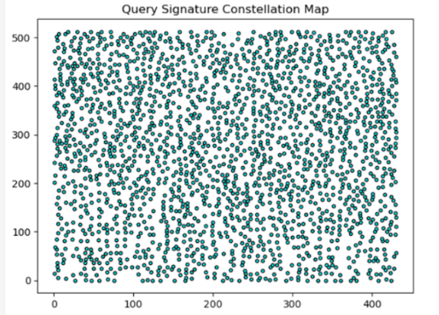
Performance Evaluation: Single Peaks vs. Combinatorial Pairs
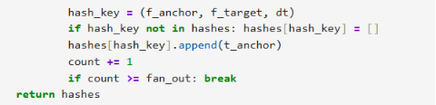
To evaluate matching uniqueness, we benchmarked two distinct retrieval strategies against our database:
Strategy 1: Single Peak Matching
- Mechanism: The lookup key relies entirely on isolated coordinates: Key = f1
- Resulting Graph Observation: The time-offset histogram shows flat, chaotic background distribution with high noise floors across all offsets.
- Explanation: A single frequency value is highly ambiguous. In any standard pop music catalog, common musical tones (e.g., A₄= 440 Hz) repeat millions of times across thousands of tracks. This generates massive false collisions across random time offsets, completely masking the true track alignment.
Strategy 2: Combinatorial Paired Hashing (Shazam Paradigm)
- Mechanism: An anchor peak is linked to a target peak inside a downstream target zone, creating a composite signature key: Key = (f_{anchor}, f_{target}, Δt).
- Resulting Graph Observation: The time-offset histogram collapses into flat background noise except at one precise coordinate, where a sharp, unambiguous True Time Alignment Spike emerges.
- Explanation: Grouping two distinct frequencies along with their exact relative time delta exponentially scales the entropy of the lookup key. The probability of an incorrect track accidentally replicating an identical pair of frequencies separated by the exact same fractional millisecond interval is near zero. When checking the correct song, all true pairs point to the exact same relative playback delay offset (Δt_{offset} = t_{db} – t_{query}), causing them to stack cleanly into a single spike
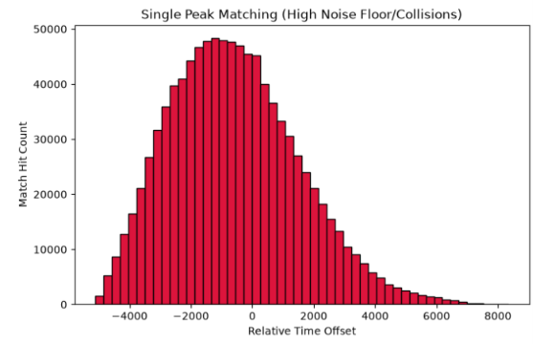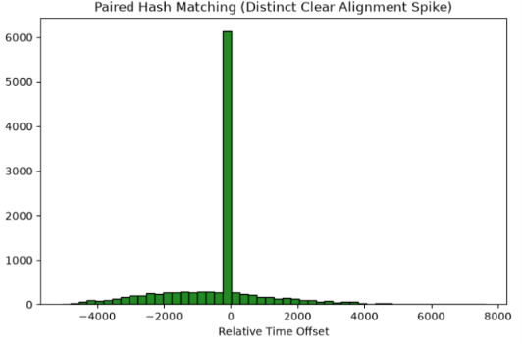
5. Robustness & Vulnerability Analysis
Experiment 1: Environmental White Noise Intrusion
- Observations: The matching engine maintains correct identification scores even when substantial additive white Gaussian noise is mixed into the query stream (down to 0dB SNR).
- Explanation: White noise spreads its energy uniformly across the entire spectral canvas. Because the fingerprinting pipeline uses a high relative magnitude threshold and targets local maxima, the prominent peaks of the primary track rise well above the noise floor. The top layers of the constellation map remain intact and match successfully.
Experiment 2: Pitch Shifting and Time Stretching
- Observations: Modifying the playback speed or applying a small pitch shift ($≥$ 2%) causes the system to fail completely, returning an alignment score of zero.
- Explanation: Pitch shifting shifts all frequencies linearly (f_{shifted} = α•f). Because our indexing engine relies on exact integer lookups for hash keys like (f_{anchor}, f_{target}, Δt), even a subtle shift shifts the peaks into entirely different frequency bins on the spectrogram grid. The modified keys fail to match the original entries in the database, breaking the alignment histogram even though the track still sounds recognizable to a human listener.
Robustness Histograms - Successful Match under Noise vs. Failed Match under Pitch Shift
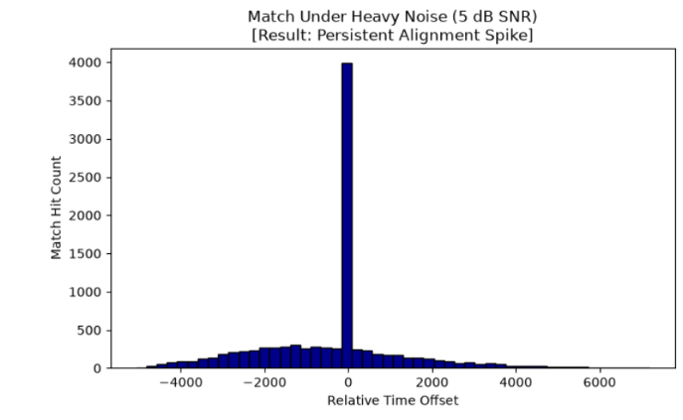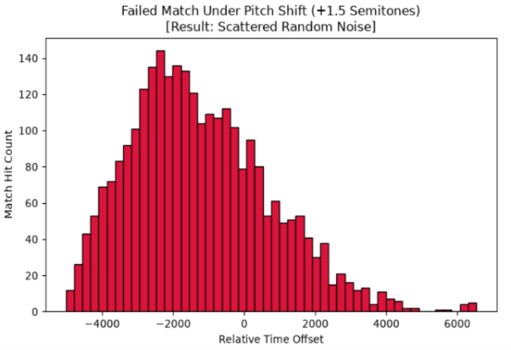
6. Architectural Improvement Proposal
To make the algorithm resilient against pitch shifts, the coordinate matching framework can be updated to use Logarithmic Frequency Ratios instead of absolute bin frequencies.
Instead of registering absolute values (f_{anchor} & f_{target}), we can calculate the pitch invariant distance:
$$ΔPitch=\log_{2}\left(f_{target}\right)- \log_{2}{(f_{anchor})}$$
When an audio clip is pitched up or down uniformly, both the anchor and target frequencies scale by the exact same multiplier $\alpha$. Because the scaling factor cancels out during division:
$$\frac{α∙ f_{target}}{α∙ f_{anchor}}=\frac{f_{target}}{f_{anchor}}$$
The ratio remains completely constant. Updating the hash template to Key_{robust} = (Δ Pitch, Δ t) the matching engine to correctly identify pitch-shifted tracks.

